연습문제 해답
<1장 연습문제 해 답>

- 연결연산자 1번 문제 답:

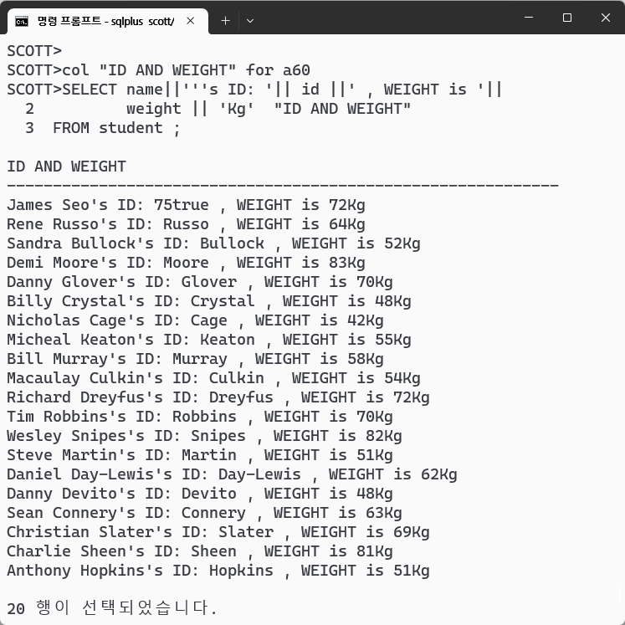

- 연결 연산자 2번 문제 답:

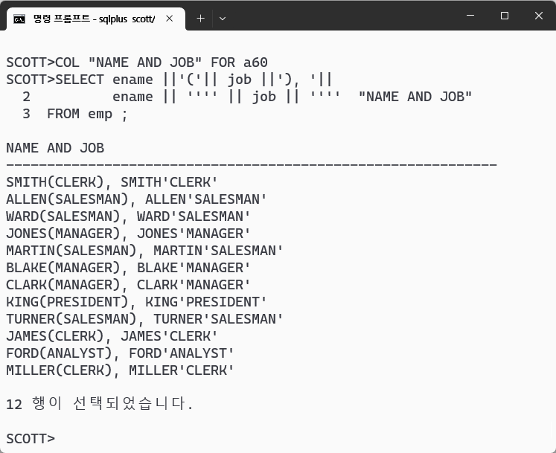
- 연결 연산자 3번 문제 답:

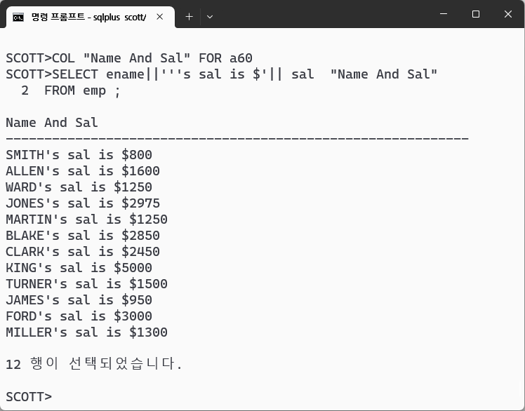

<2장 일반함수 연습문제 해답>

- SUBSTR / INSTR 퀴즈 답:

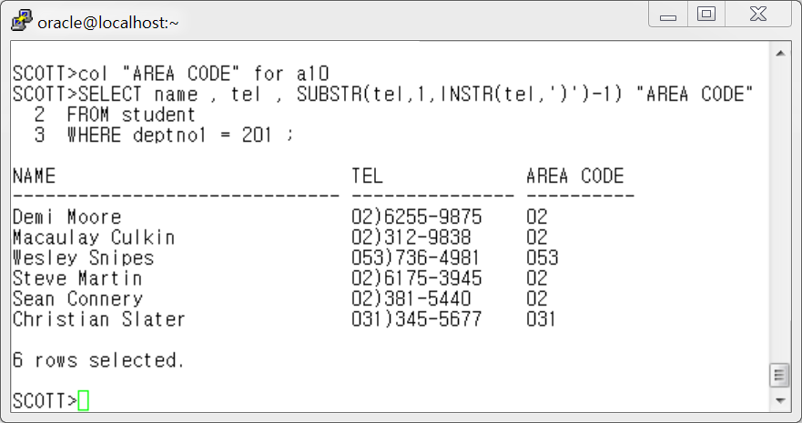

- LPAD 퀴즈 답:

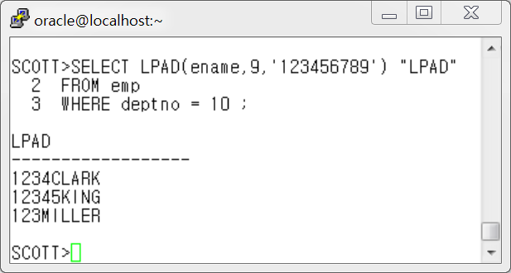

- RPAD 퀴즈 답 :

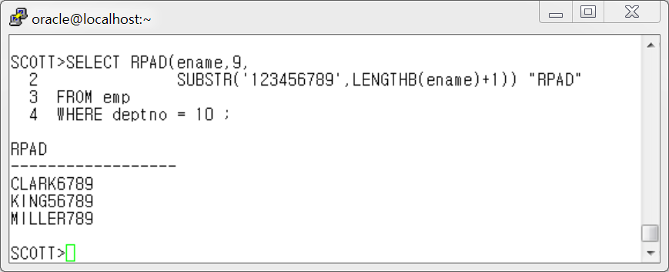

- REPLACE 퀴즈 1 답 :

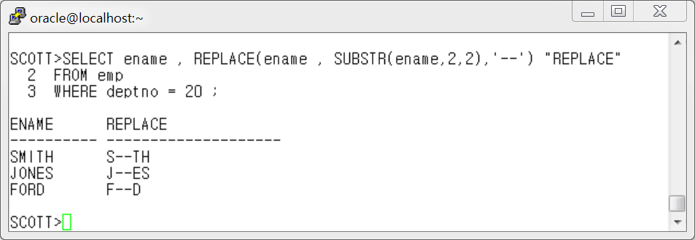

- REPLACE 퀴즈 2 답 :

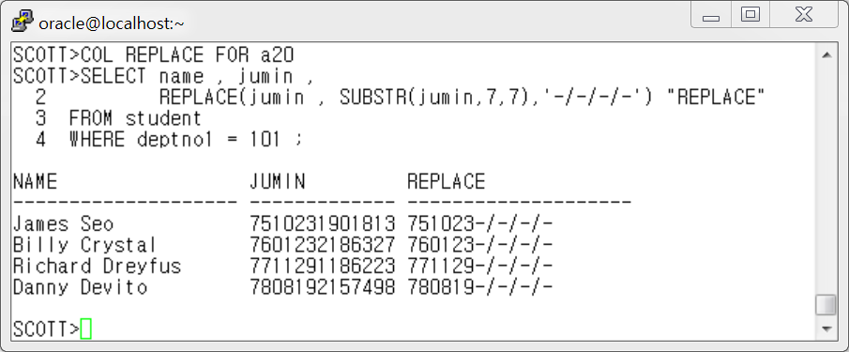

- REPLACE 퀴즈 3 답:

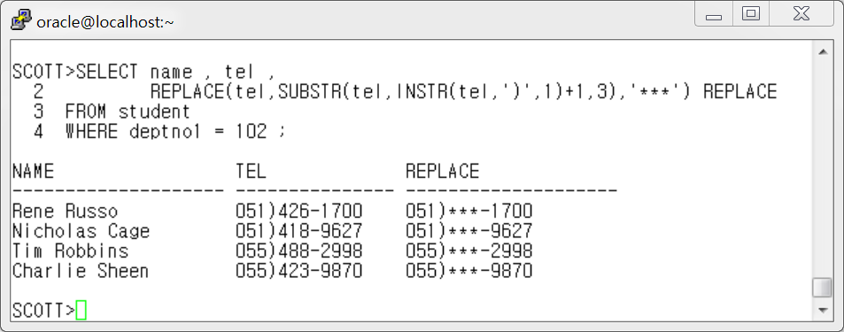

- REPLACE 퀴즈 4 답:

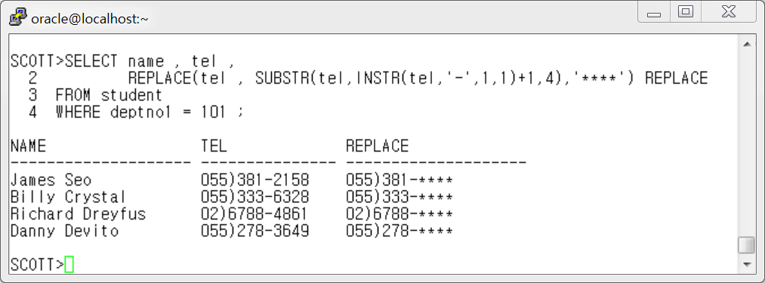

- 형 변환 함수 퀴즈-날짜변환하기 1 **

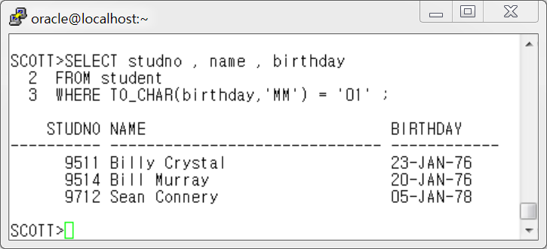

- 형 변환 함수 퀴즈-날짜변환하기 2

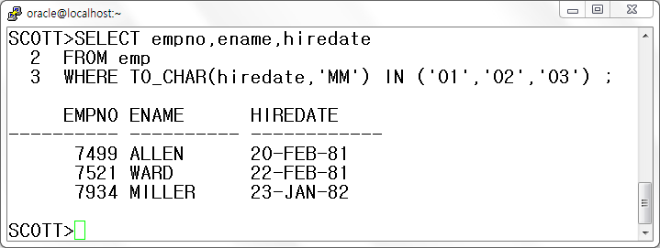

- 형변환 함수 퀴즈 3

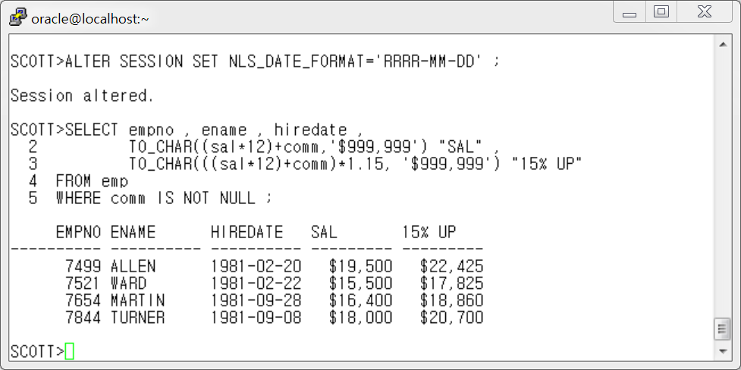

- NVL 함수 퀴즈

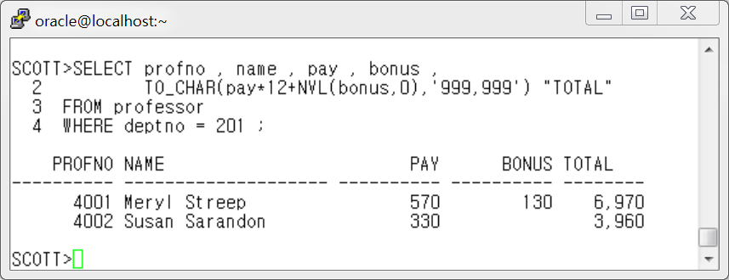

- NVL2 함수 퀴즈

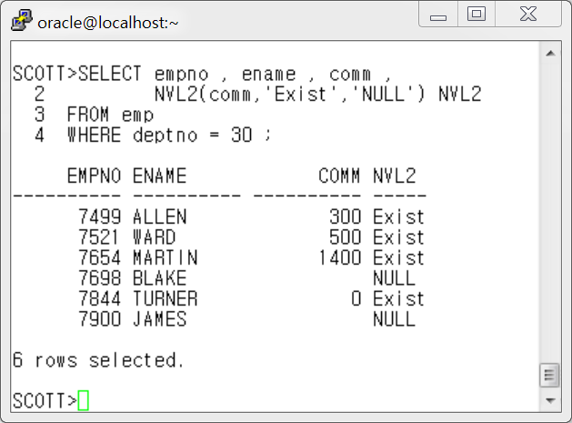

- DECODE 연습 문제 1 답:

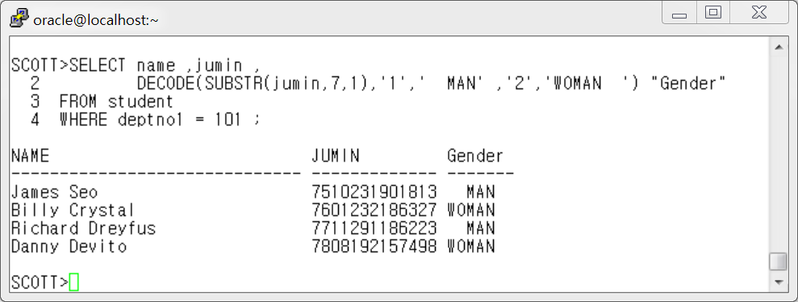

- DECODE 연습 문제 2 답:

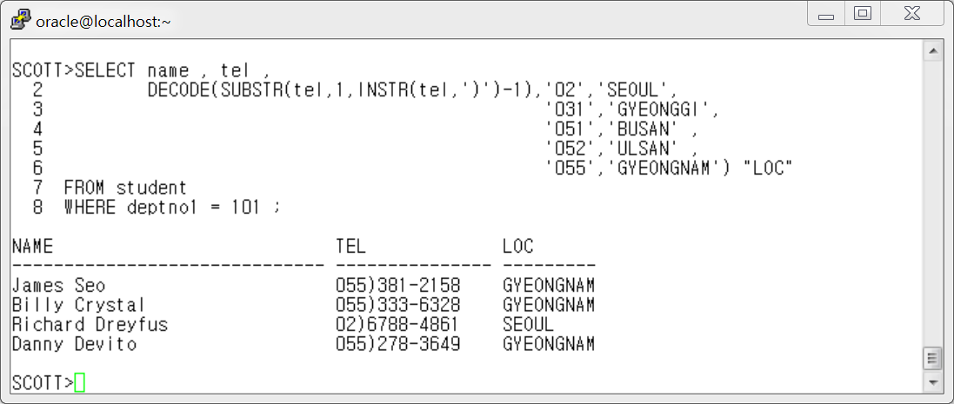

- CASE 식 연습문제 답

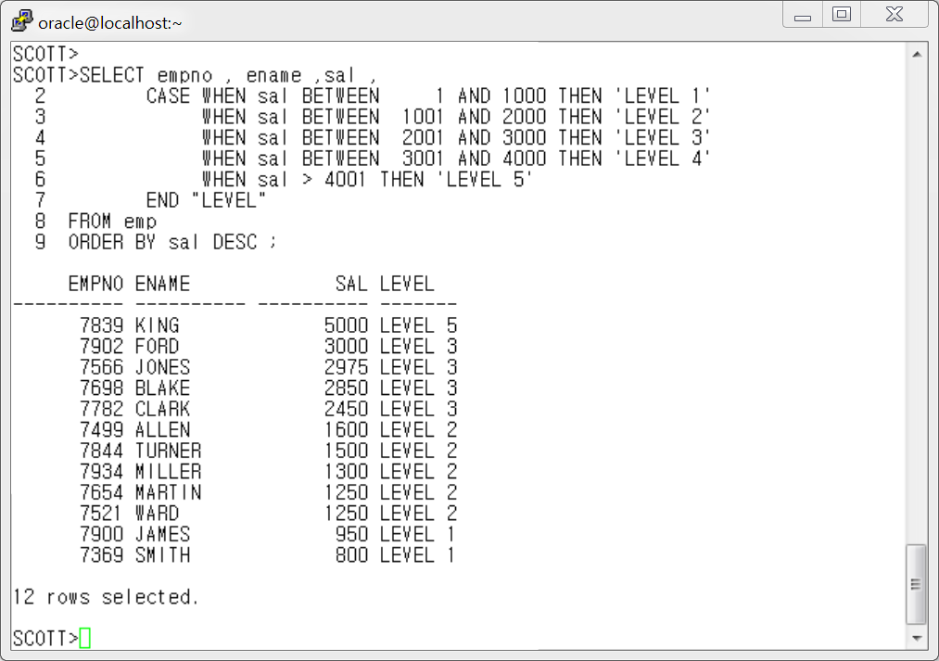

< 3장 그룹함수 연습문제 해답>

- 1번 답 :
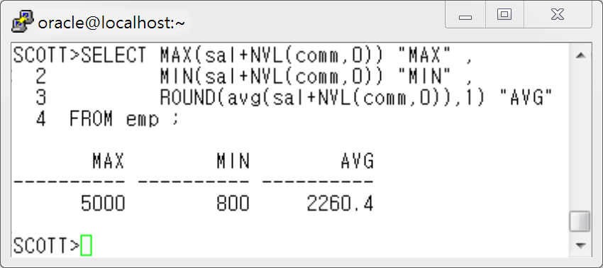

- 2번 답 :

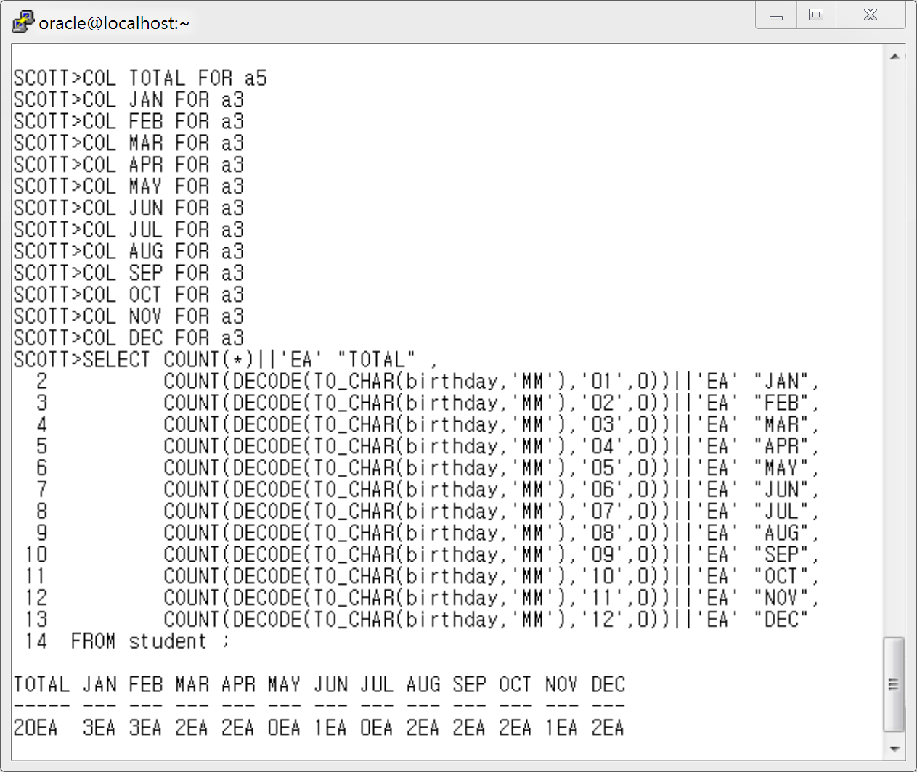

- 3 번 답:

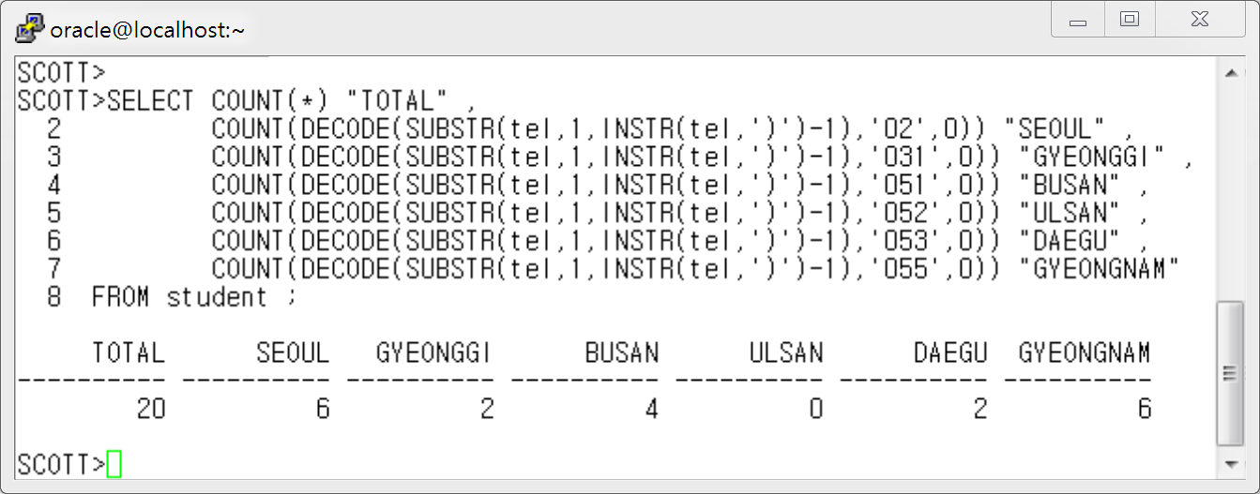

4 번 답 :

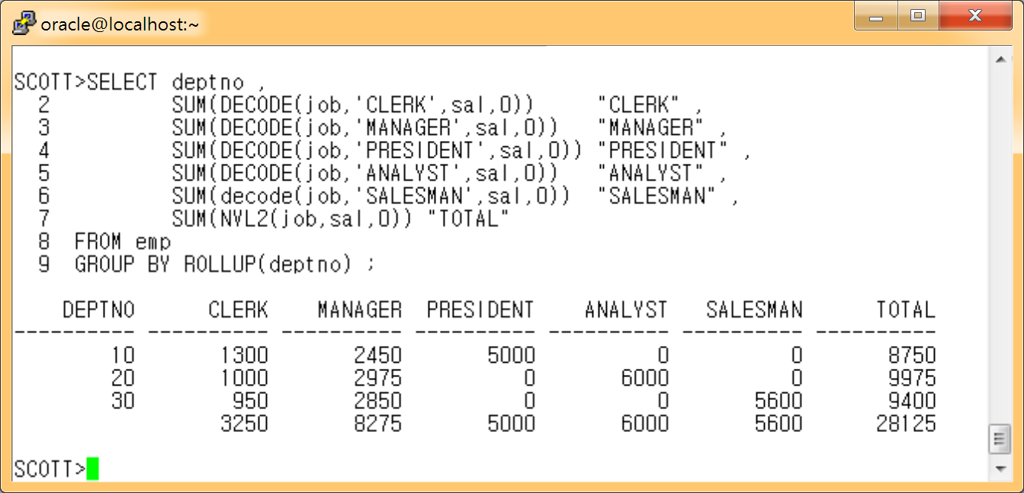

5 번 답 :

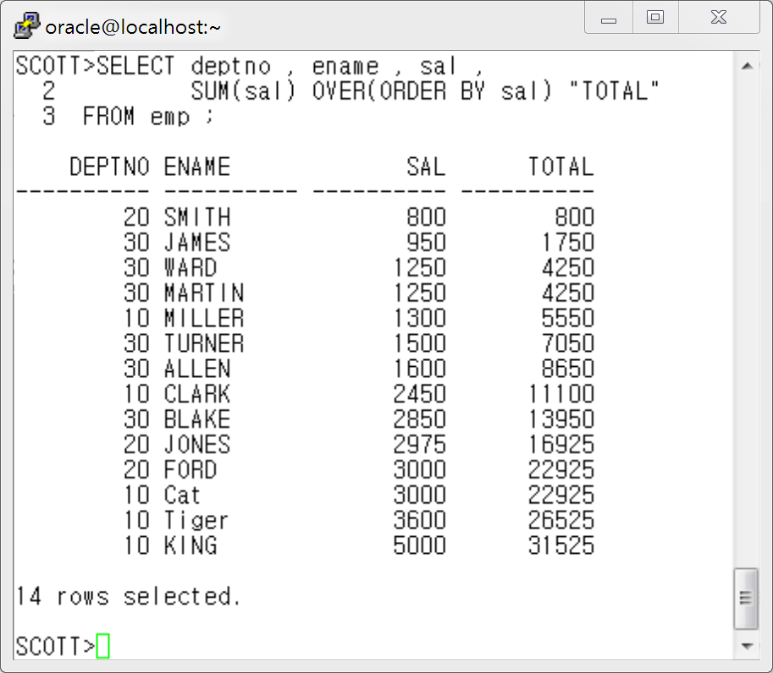

6 번 답 :
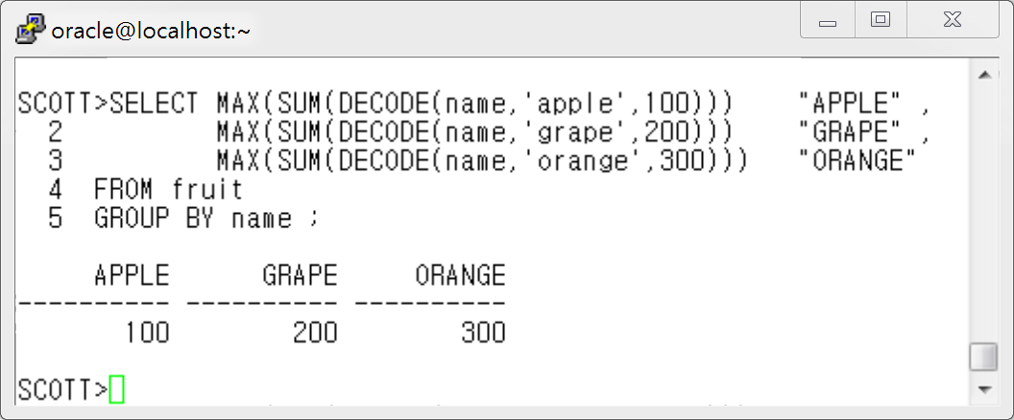

7번 답:

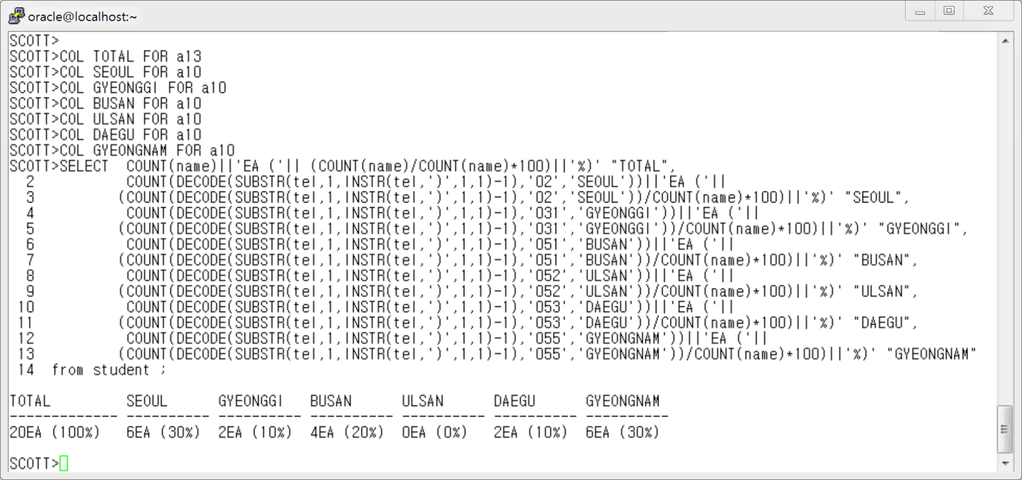

SCOTT>COL TOTAL FOR a13
SCOTT>COL SEOUL FOR a10
SCOTT>COL GYEONGGI FOR a10
SCOTT>COL BUSAN FOR a10
SCOTT>COL ULSAN FOR a10
SCOTT>COL DAEGU FOR a10
SCOTT>COL GYEONGNAM FOR a10
SCOTT>SELECT COUNT(name)||'EA ('|| (COUNT(name)/COUNT(name)*100)||'%)' "TOTAL",
2 COUNT(DECODE(SUBSTR(tel,1,INSTR(tel,')',1,1)-1),'02','SEOUL'))||'EA ('||
3 (COUNT(DECODE(SUBSTR(tel,1,INSTR(tel,')',1,1)-1),'02','SEOUL'))/COUNT(name)*100)||'%)' "SEOUL",
4 COUNT(DECODE(SUBSTR(tel,1,INSTR(tel,')',1,1)-1),'031','GYEONGGI'))||'EA ('||
5 (COUNT(DECODE(SUBSTR(tel,1,INSTR(tel,')',1,1)-1),'031','GYEONGGI'))/COUNT(name)*100)||'%)' "GYEONGGI",
6 COUNT(DECODE(SUBSTR(tel,1,INSTR(tel,')',1,1)-1),'051','BUSAN'))||'EA ('||
7 (COUNT(DECODE(SUBSTR(tel,1,INSTR(tel,')',1,1)-1),'051','BUSAN'))/COUNT(name)*100)||'%)' "BUSAN",
8 COUNT(DECODE(SUBSTR(tel,1,INSTR(tel,')',1,1)-1),'052','ULSAN'))||'EA ('||
9 (COUNT(DECODE(SUBSTR(tel,1,INSTR(tel,')',1,1)-1),'052','ULSAN'))/COUNT(name)*100)||'%)' "ULSAN",
10 COUNT(DECODE(SUBSTR(tel,1,INSTR(tel,')',1,1)-1),'053','DAEGU'))||'EA ('||
11 (COUNT(DECODE(SUBSTR(tel,1,INSTR(tel,')',1,1)-1),'053','DAEGU'))/COUNT(name)*100)||'%)' "DAEGU",
12 COUNT(DECODE(SUBSTR(tel,1,INSTR(tel,')',1,1)-1),'055','GYEONGNAM'))||'EA ('||
13 (COUNT(DECODE(SUBSTR(tel,1,INSTR(tel,')',1,1)-1),'055','GYEONGNAM'))/COUNT(name)*100)||'%)' "GYEONGNAM"
14 from student ;

TOTAL SEOUL GYEONGGI BUSAN ULSAN DAEGU GYEONGNAM
------------- ---------- ---------- ---------- ---------- ---------- ----------
20EA (100%) 6EA (30%) 2EA (10%) 4EA (20%) 0EA (0%) 2EA (10%) 6EA (30%)

8번 답:

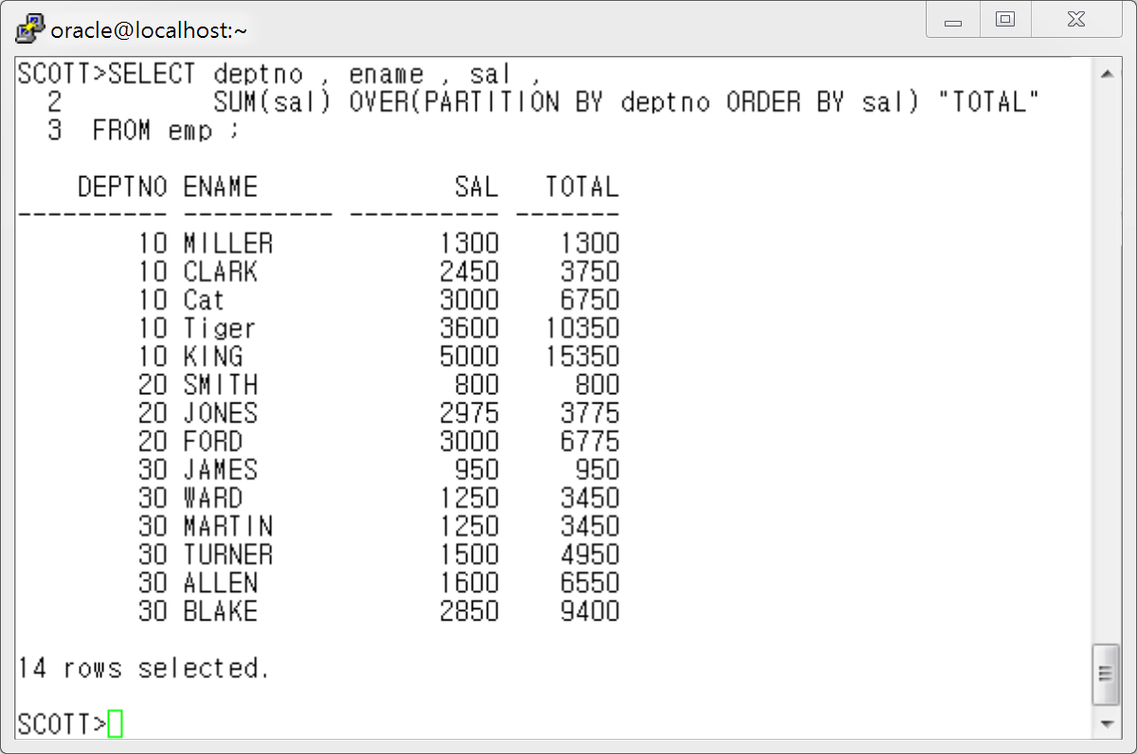

9번 답 :

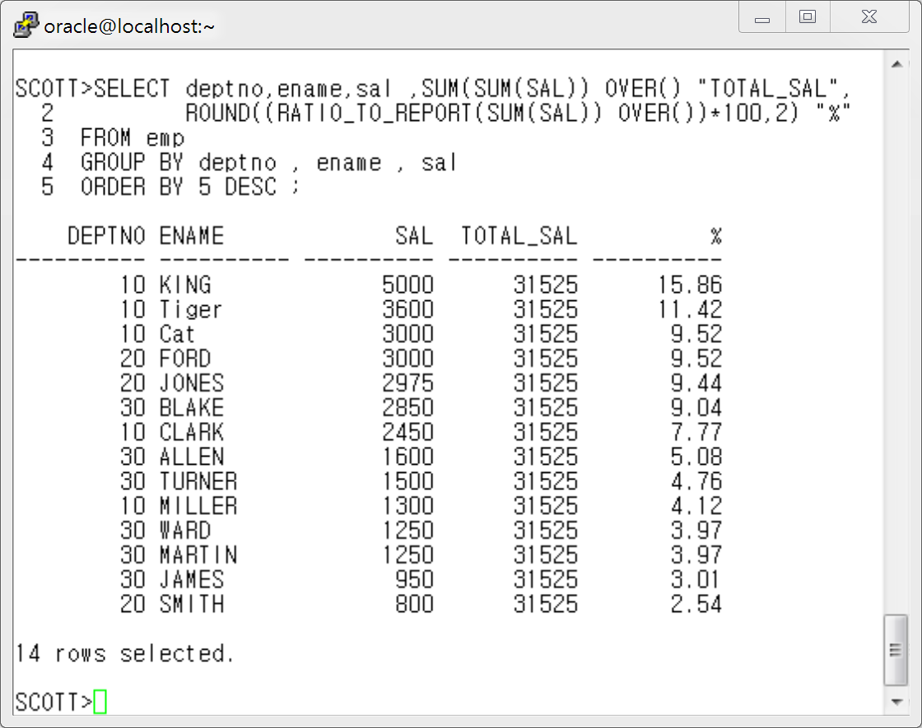

10번 답 :

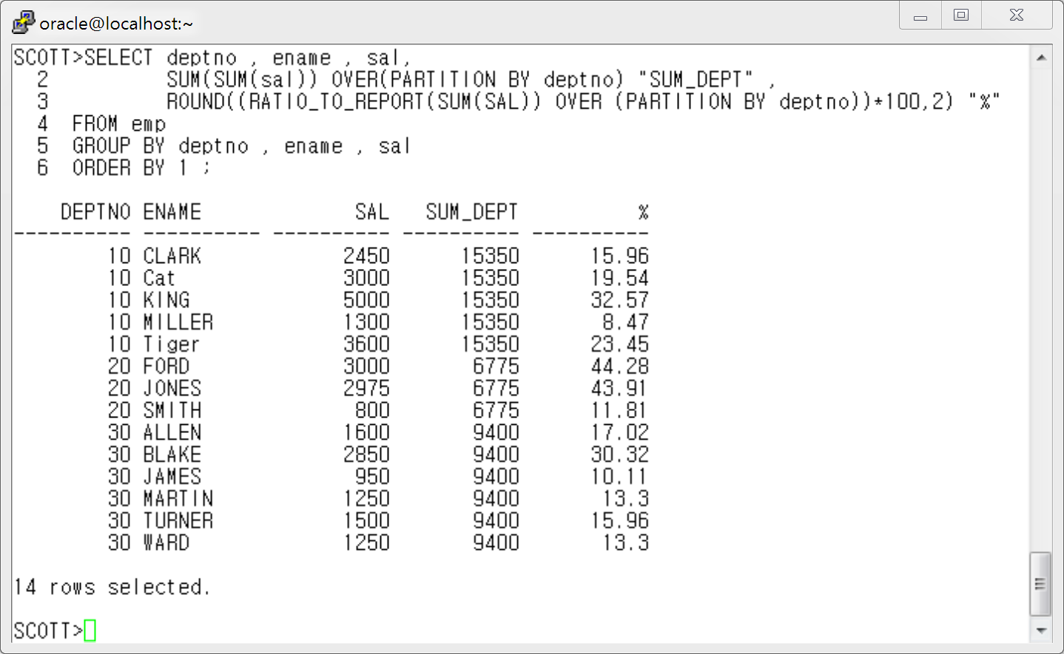

11번답 )
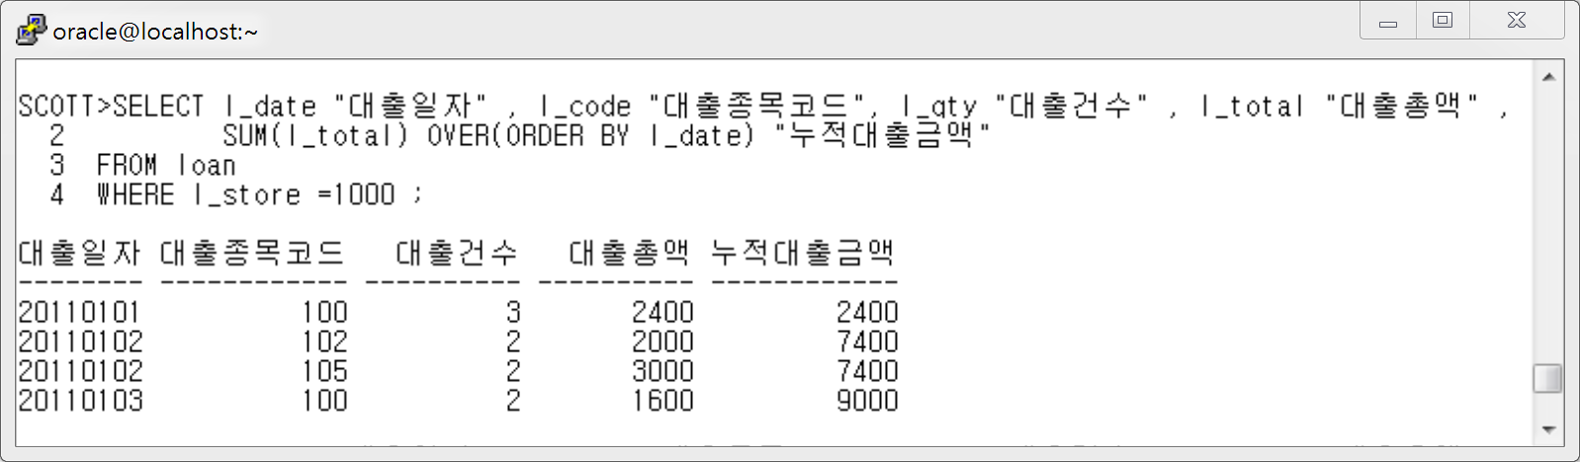

12번 답)
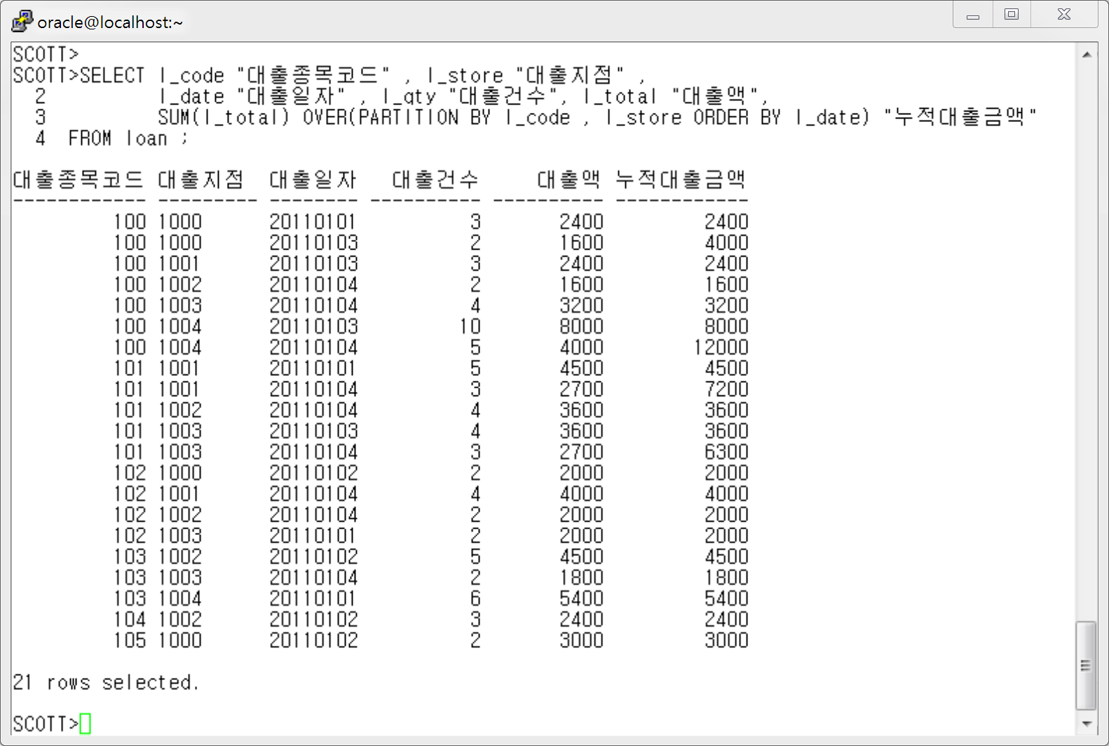

13번 답)
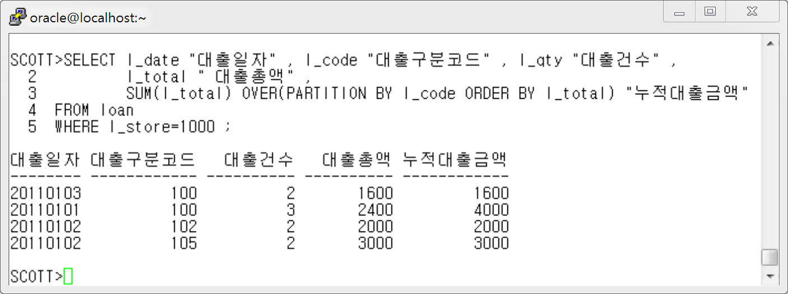

14번 답)
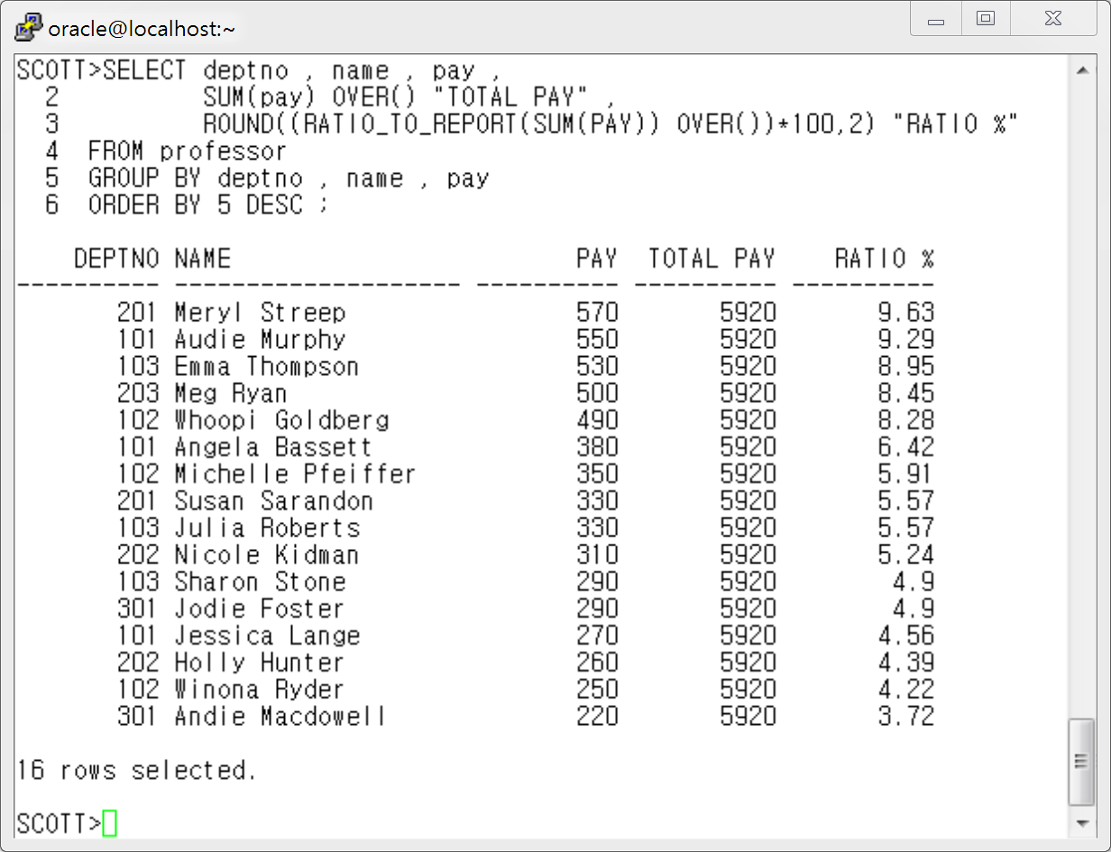

15번 답)

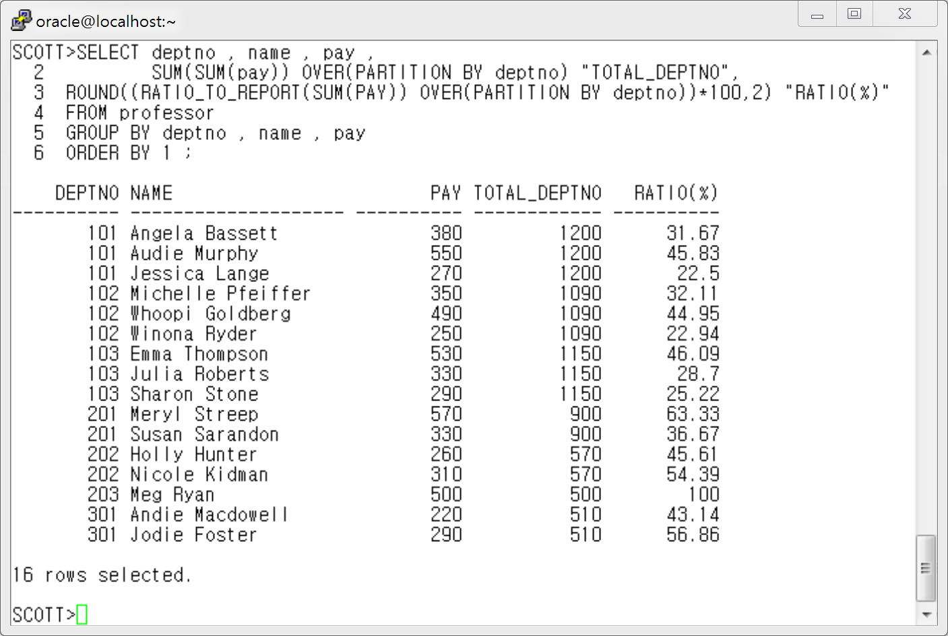

< 4장 Join 연습문제 해답>

1 번 답)
[ Oracle Join 문법 ]

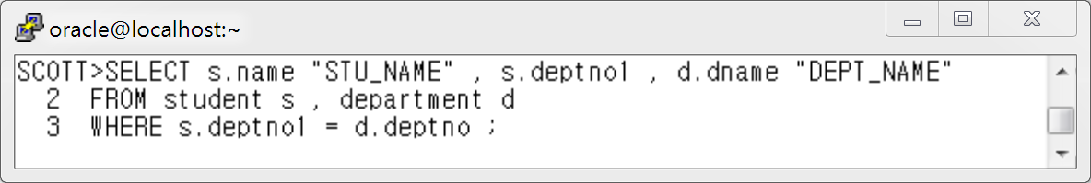

[ ANSI Join 문법 ]

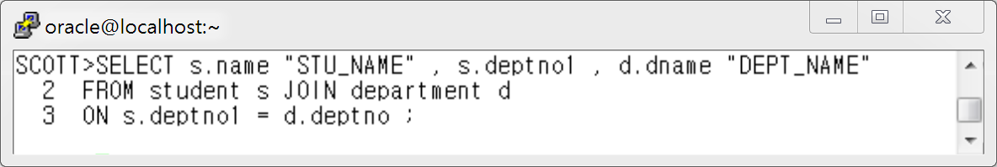

2 번 답 )
[ Oracle Join 문법 ]

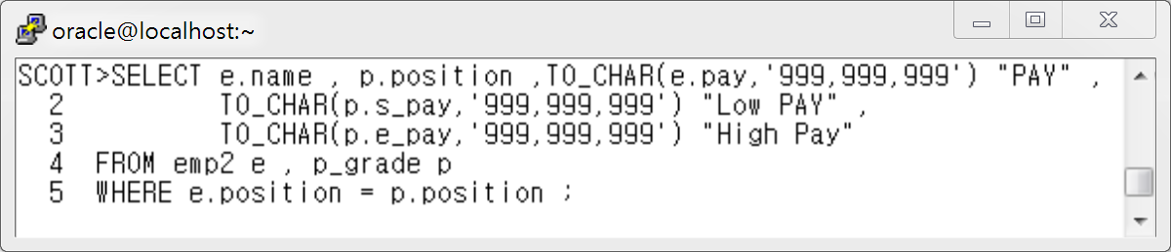

[ ANSI Join 문법 ]

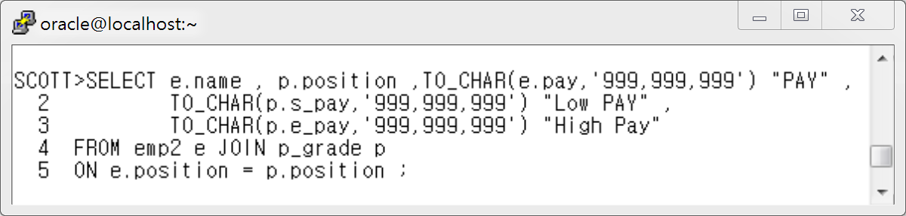

3번 답)
[ Oracle Join 문법 ]

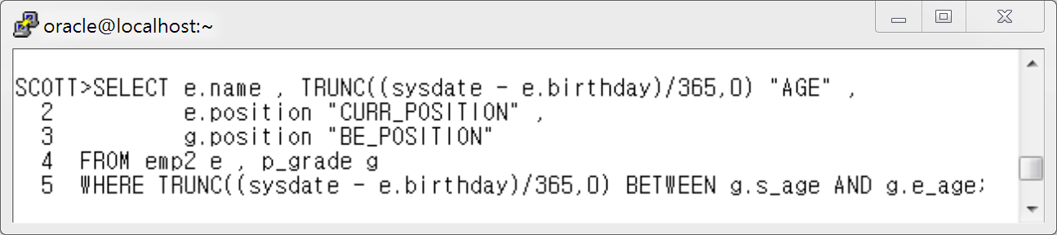

[ ANSI Join 문법 ]

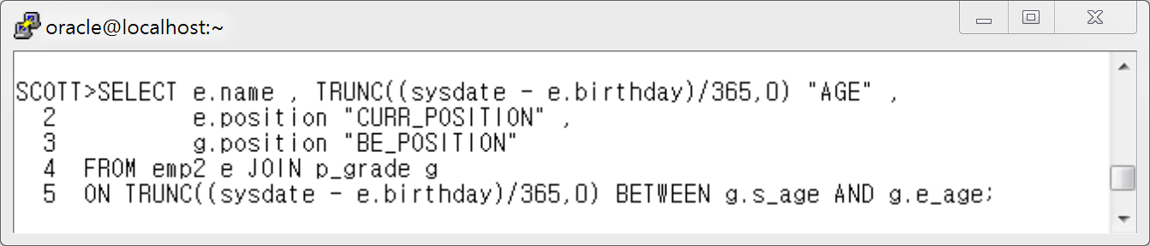

4번 답)
[ Oracle Join 문법 ]

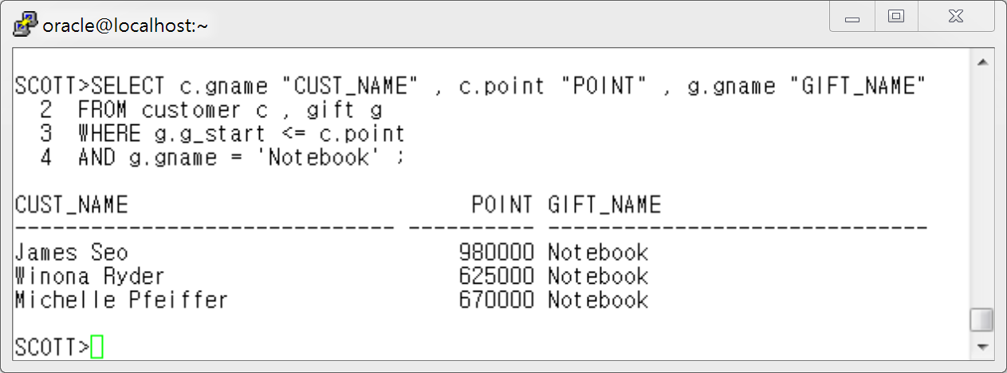

[ ANSI Join 문법 ]

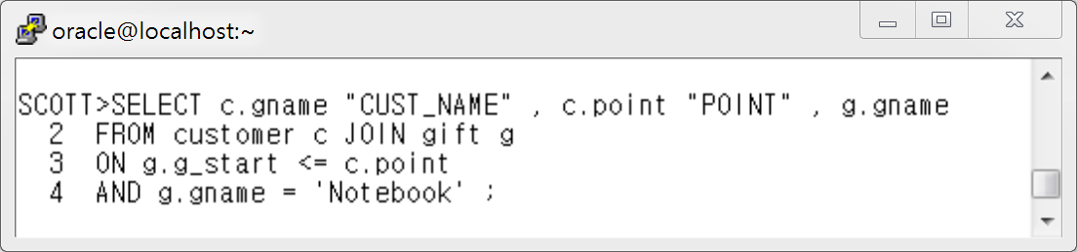
5번 답)
[ Oracle Join 문법 ]

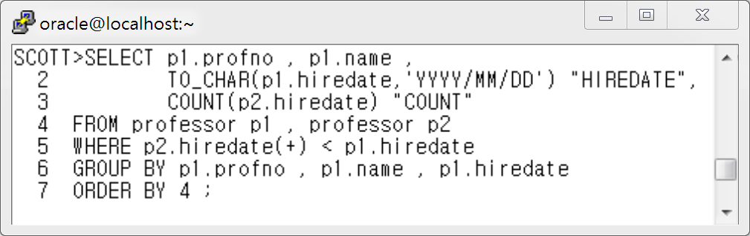

[ ANSI Join 문법 ]

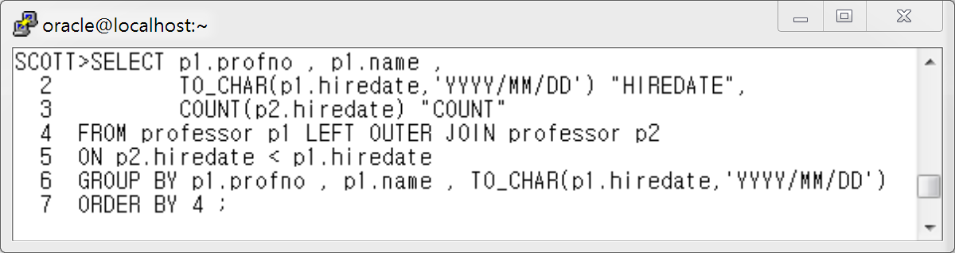

6번 답 )
[ Oracle Join 문법 ]

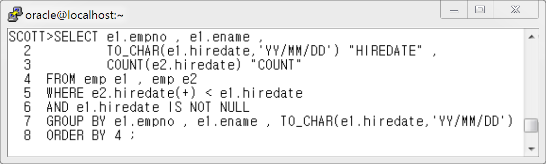

[ ANSI Join 문법 ]

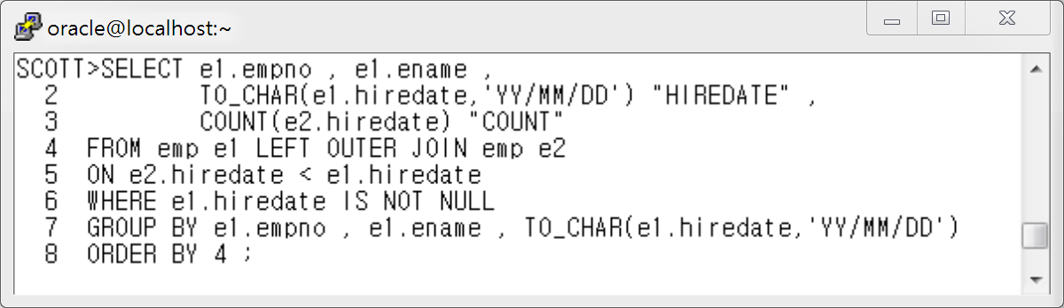
< 5장 DDL 연습문제 답 >

- 1번 답 :
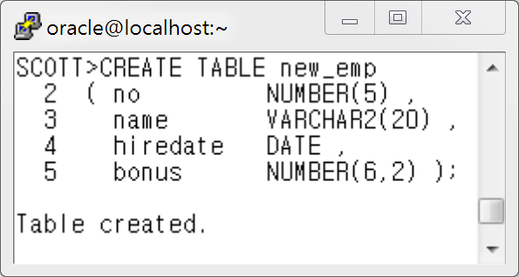

- 2번 답 :
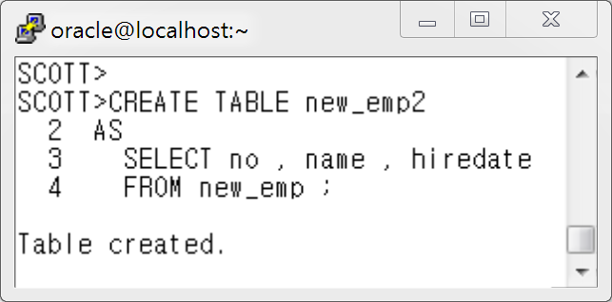

- 3번 답 :
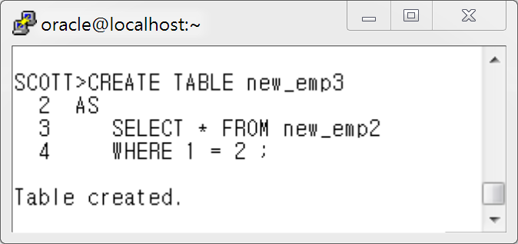

-4번 답 :
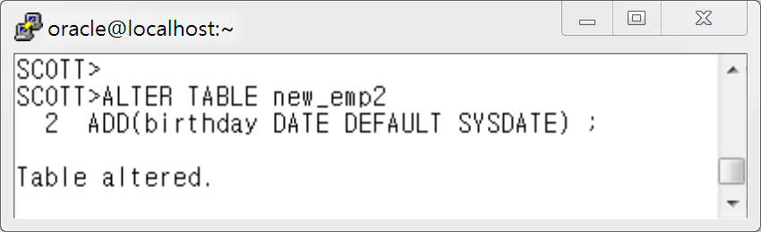

- 5번 답 :
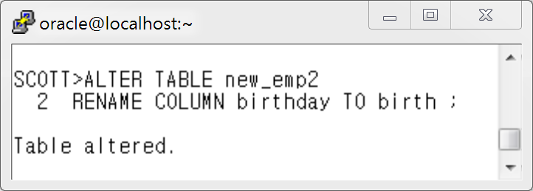

- 6번 답 :
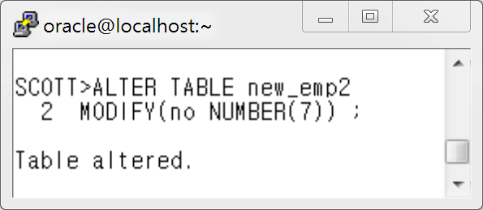

- 7번 답 :
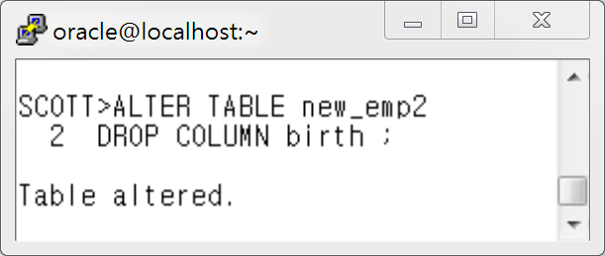

-8번 답 :
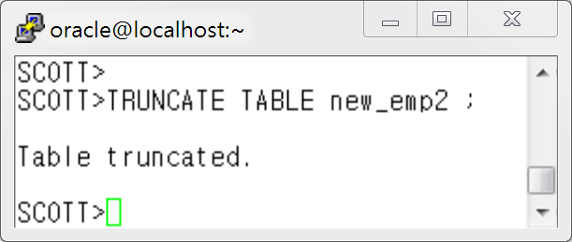

-9번 답 :
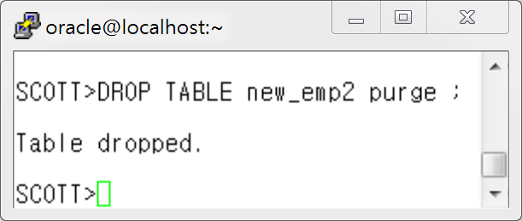

<6 장 DML 연습문제 정답>
- 1번 답: INSERT INTO dept2 VALUES('9010','temp_10','1006','temp area') ;

- 2번 답: INSERT INTO dept2(DCODE , DNAME , PDEPT) VALUES('9020','temp_20','1006') ;

- 3번 답:
INSERT INTO professor4
SELECT profno, name, pay
FROM professor
WHERE profno <= 3000 ;

- 4번 답:
UPDATE professor
SET bonus = 100
WHERE name = ''Sharon Stone' ;

<7장 연습문제 정답>

- 1번 답 :
CREATE TABLE tcons
( no NUMBER(4)
CONSTRAINT tcons_no_pk PRIMARY KEY ,
name VARCHAR2(20)
CONSTRAINT tcons_name_nn NOT NULL,
jumin VARCHAR2(13)
CONSTRAINT tcons_jumin_nn NOT NULL
CONSTRAINT tcons_jumin_uk UNIQUE ,
area NUMBER(1)
CONSTRAINT tcons_area_ck CHECK ( loc_code < 5 ),
deptno VARCHAR2(6)
CONSTRAINT tcons_deptno_fk REFERENCES dept2(dcode)
) ;

- 2번 답:
ALTER TABLE tcons
ADD CONSTRAINT tcons_name_fk FOREIGN KEY(name)
REFERENCES emp2(name) ;

- 3번 답:
ALTER TABLE tcons
DISABLE VALIDATE CONSTRAINT tcons_jumin_uk ;

- 4번 답:
ALTER TABLE scott.tcons ENABLE VALIDATE CONSTRAINT tcons_jumin_uk
EXCEPTIONS INTO scott.execptions;

- 5번 답:
SELECT owner , constraint_name , table_name , column_name
FROM user_cons_columns
WHERE table_name='EMP';

<9 장 View 연습문제 정답>
- 1번 답 :
SCOTT>CREATE OR REPLACE VIEW v_prof_dept
2 AS
3 SELECT p.profno "교수번호"
4 , p.name "교수명"
5 , d.dname "소속학과명"
6 FROM professor p , department d
7 WHERE p.deptno = d.deptno ;

- 2번 답 :
SCOTT> SELECT d.dname
2 , s.max_height
3 , s.max_weight
4 FROM ( SELECT deptno1, MAX(height) max_height, MAX(weight) max_weight
5 FROM student
6 GROUP BY deptno1) s , department d
7 WHERE s.deptno1 = d.deptno ;

- 3번 답 :
SCOTT> SELECT d.dname , a.max_height , s.name , s.height
2 FROM ( SELECT deptno1, MAX(height) max_height
3 FROM student
4 GROUP BY deptno1) a , student s, department d
5 WHERE s.deptno1=a.deptno1
6 AND s.height = a.max_height
7 AND s.deptno1=d.deptno ;

- 4번 답 :
SCOTT>SELECT s.grade , s.name , s.height , a.avg_height
2 FROM ( SELECT grade , AVG(height) avg_height
3 FROM student
4 GROUP BY grade) a , student s
5 WHERE a.grade = s.grade
6 AND s.height > a.avg_height
7 ORDER BY 1 ;

- 5번 답:
SCOTT>SELECT rownum "Ranking" , name , pay
2 FROM ( SELECT name , pay
3 FROM professor
4 ORDER BY 2 desc )
5 WHERE rownum BETWEEN 1 and 5 ;

- 6번 답:
SCOTT>SELECT num , profno , name , pay ,sum(pay) , round(avg(pay),1)
2 FROM (SELECT profno , name , pay , rownum num
3 FROM professor )
4 GROUP BY CEIL(num/3) , ROLLUP((profno , name , pay , num))
5 ORDER BY CEIL(num/3) ;

< 10장 Sub Query 연습문제 해답>

단일행 서브쿼리 문제 1 답

SCOTT> SELECT s.name "STUD_NAME" , d.dname "DEPT_NAME"
2 FROM student s , department d
3 WHERE s.deptno1=d.deptno
4 and s.deptno1 = ( SELECT deptno1
5 FROM student
6 WHERE name='Anthony Hopkins') ;

단일행 서브쿼리 연습문제 2 답
SCOTT>SELECT p.name "PROF_NAME" , p.hiredate ,d.dname "DEPT_NAME"
2 FROM professor p , department d
3 WHERE p.deptno = d.deptno
4 AND hiredate > ( SELECT hiredate
5 FROM professor
6 WHERE name='Meg Ryan') ;

단일행 서브쿼리 연습문제 3 답:
SCOTT>SELECT name , weight
2 FROM student
3 WHERE weight > ( SELECT avg(weight)
4 FROM student
5 WHERE deptno1=201) ;

다중행 서브쿼리 연습문제 1 답:
SCOTT> SELECT name , position ,
2 TO_CHAR(pay,'$999,999,999') "SALARY"
3 FROM emp2
4 WHERE pay > ANY (SELECT pay
5 FROM emp2
6 WHERE position='Section head') ;

다중행 서브쿼리 연습문제 2 답:
SCOTT> SELECT name , grade , weight
2 FROM student
3 WHERE weight < ALL (SELECT weight
4 FROM student
5 WHERE grade = 2 ) ;

다중 행 서브쿼리 연습문제 3 답:
SCOTT>SELECT d.dname , e.name ,to_char( e.pay,'$999,999,999') "SALARY"
2 FROM emp2 e , dept2 d
3 WHERE e.deptno=d.dcode
4 AND e.pay < ALL (SELECT AVG(pay)
5 FROM emp2
6 GROUP BY deptno )
7 ORDER BY 3 ;

다중 컬럼 서브쿼리 연습문제 1 답 :
SCOTT>SELECT p.profno "PROFNO" ,p.name "PROF_NAME",
2 p.hiredate , d.dname "DEPT_NAME"
3 FROM professor p , department d
4 WHERE p.deptno=d.deptno
5 AND (p.deptno , p.hiredate) IN (SELECT deptno,MIN(hiredate)
6 FROM professor
7 GROUP BY deptno )
8 ORDER BY 3 ;

다중 컬럼 서브쿼리 연습문제 2 답:
SCOTT>SELECT name , position , TO_CHAR(pay,'$999,999,999') "SALARY"
2 FROM emp2
3 WHERE (position,pay) IN ( SELECT position, MAX(pay)
4 FROM emp2
5 GROUP BY position )
6 ORDER BY 3 ;

< 12장 계층형 쿼리 연습문제 답>

- 1번 답:
SCOTT> SELECT LPAD(e.name||'-'||d.dname||'-'||
2 NVL(e.position,'Worker'),LEVEL*27,'-') "Name And Position"
3 FROM emp2 e, (SELECT dname,dcode,pdept
4 FROM dept2) d
5 WHERE e.deptno = d.dcode
6 CONNECT BY PRIOR e.empno = e.pempno
7 START WITH e.empno = 19900101 ;

- 1번-2 답:
SCOTT> SELECT LPAD(e.name||'-'||d.dname||'-'||
2 NVL(e.position,'Worker'),LEVEL*27,'-') "Name And Position"
3 FROM emp2 e, (SELECT dname,dcode,pdept
4 FROM dept2) d
5 WHERE e.deptno = d.dcode
6 CONNECT BY PRIOR e.empno = e.pempno
7 START WITH e.empno = 19900101
8 ORDER SIBLINGS BY e.name ;

- 2번 답:
SCOTT> SELECT LPAD(e.name||'-'||d.dname||'-'||
2 NVL(e.position,'Worker'),LEVEL*27,'-') "Name And Position"
3 FROM emp2 e, (SELECT dname,dcode,pdept
4 FROM dept2) d
5 WHERE e.deptno = d.dcode
6 CONNECT BY PRIOR e.empno = e.pempno
7 START WITH e.empno = 19966102 ;

- 3번 답:
SCOTT> SELECT
2 LPAD(e.name||'-'||d.dname||'-'||NVL(e.position,'Worker'),LEVEL*25,'-') "Name And Position"
3 FROM emp2 e, (SELECT dname,dcode,pdept
4 FROM dept2) d
5 WHERE e.deptno = d.dcode
6 CONNECT BY e.empno = PRIOR e.pempno
7 START WITH e.empno = 20000334 ;

- 4번 답:
SCOTT> SELECT name "NAME" , PRIOR name "MGR_NAME"
2 FROM emp2
3 START WITH pempno IS NULL
4 CONNECT BY PRIOR empno=pempno ;

- 5번 답:
SCOTT>COL ename FOR a58
SCOTT>SELECT empno , name||'-'||d.dname||'-'||NVL(a.position,'Worker') "ENAME" ,
2 (SELECT COUNT(*)
3 FROM emp2
4 START WITH empno = a.empno
5 CONNECT BY PRIOR empno = pempno) -1 "COUNT"
6 FROM emp2 a , ( SELECT dname , dcode
7 FROM dept2 ) d
8 WHERE a.deptno = d.dcode
9 ORDER BY 3 DESC ;

6번 답
SCOTT>COL "Name And Position" FOR a70
SCOTT>COL "PATH" FOR a50
SCOTT>SELECT
2 LPAD(e.name||' '||d.dname||' '||NVL(e.position,'Worker'),LEVEL*18,'-') "Name And Position"
3 ,SYS_CONNECT_BY_PATH(e.name,'-') "PATH"
4 FROM emp2 e, (SELECT dname,dcode,pdept
5 FROM dept2) d
6 WHERE e.deptno = d.dcode
7 CONNECT BY PRIOR e.empno = e.pempno ;
8 START WITH e.empno = 19966102 ;

< 15장 PL/SQL 변수사용하기 연습문제 답 >
1번 답 :
SCOTT>SET SERVEROUTPUT ON ;
SCOTT>DECLARE
2 v_empno emp.empno%TYPE ;
3 v_ename emp.ename%TYPE ;
4 v_deptno dept.deptno%TYPE ;
5 v_dname dept.dname%TYPE ;
6
7 BEGIN
8 SELECT e.empno, e.ename, d.deptno, d.dname
9 INTO v_empno, v_ename, v_deptno, v_dname
10 FROM emp e, dept d
11 WHERE e.empno=7902
12 AND e.deptno=d.deptno ;
13 DBMS_OUTPUT.PUT_LINE('EMPNO//ENAME//DEPTNO//DNAME') ;
14 DBMS_OUTPUT.PUT_LINE(v_empno||' '||v_ename||' '||v_deptno||' '||v_dname) ;
15 END ;
16 /
EMPNO//ENAME//DEPTNO//DNAME
7902 FORD 20 RESEARCH

PL/SQL procedure successfully completed.

2번 답 :
SCOTT>SET VERIFY OFF
SCOTT>SET SERVEROUTPUT ON
SCOTT>DECLARE
2 v_no1 NUMBER := &no1 ;
3 v_no2 NUMBER := &no2 ;
4 v_sum NUMBER ;
5
6 BEGIN
7 v_sum := v_no1 + v_no2 ;
8 DBMS_OUTPUT.PUT_LINE('FIRST: '||v_no1||', SECOND : '||v_no2||' , TOTAL : '||v_sum||);
9 END ;
10 /

<16장 PLSQL 제어문 익히기 연습문제 답 >

연습문제 1 답:
SQL>DECLARE
2 vempno emp.empno%TYPE;
3 vename emp.ename%TYPE;
4 vcomm emp.comm%TYPE := NULL;
5 BEGIN
6 SELECT empno , ename , comm INTO vempno , vename , vcomm
7 FROM emp
8 WHERE empno= &empno; -- 사원번호 입력 받기입니다
9
10 IF vcomm > 0 THEN
11 DBMS_OUTPUT.PUT_LINE (vename||' 사원의 보너스는 '||vcomm||'입니다');
12 ELSE
13 DBMS_OUTPUT.PUT_LINE (vename||' 사원의 보너스는 없습니다');
14 END IF ;
15 END;
16 /

연습문제 2 답:

SQL>DECLARE
2 v_empno emp.empno%TYPE := &eno ;
3 v_ename emp.ename%TYPE ;
4 v_sal emp.sal%TYPE ;
5 v_segum NUMBER ;
6 BEGIN
7 SELECT ename, sal INTO v_ename, v_sal
8 FROM emp
9 WHERE empno = v_empno ;
10
11 IF v_sal >= 5000 THEN
12 v_segum := v_sal * 0.05 ;
13 ELSIF v_sal BETWEEN 4000 AND 4999 THEN
14 v_segum := v_sal * 0.04 ;
15 ELSIF v_sal BETWEEN 3000 AND 3999 THEN
16 v_segum := v_sal * 0.03 ;
17 ELSIF v_sal BETWEEN 2000 AND 2999 THEN
18 v_segum := v_sal * 0.02 ;
19 ELSE
20 v_segum := v_sal * 0.01 ;
21 END IF ;
22
23 DBMS_OUTPUT.PUT_LINE ('입력하신 사번 '||v_empno||' 님의 연봉은 '||
24 v_sal ||' 만원이고 , 세금은 '||v_segum||' 만원입니다') ;
25 END ;
26 /

Enter value for eno: 7900
입력하신 사번 7900 님의 연봉은 950 만원이고 , 세금은 9.5 만원입니다

PL/SQL procedure successfully completed.

연습문제 3번 답 :

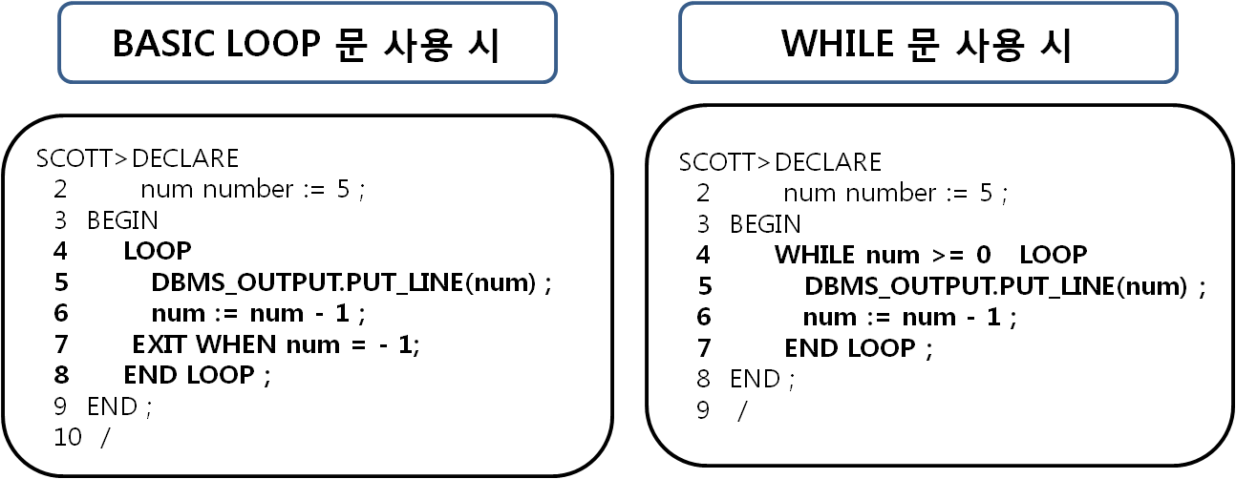

연습문제 4 답-for 반복문을 사용한 구구단 2단 출력하기
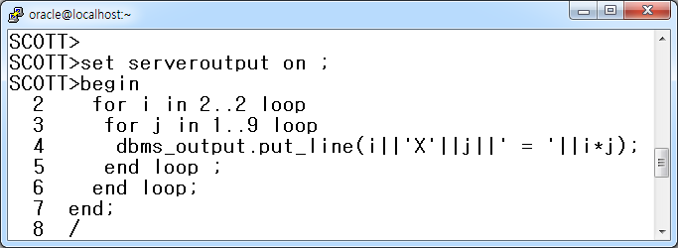

연습문제 4번 답-while 반복문을 사용한 구구단 2단 출력하기
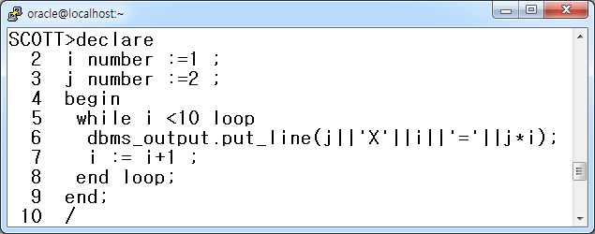

연습문제 5번 답 - for 반복문을 사용하여 원하는 단을 입력 받은 후 구구단 출력하기
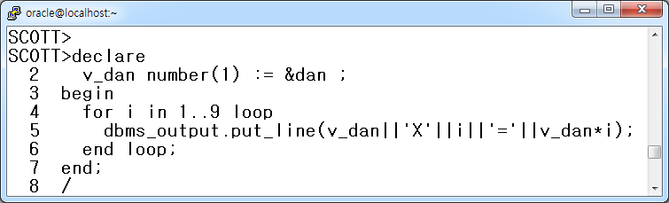

연습문제 5 답 - While 반복문을 사용하여 원하는 단을 입력 받은 후 구구단 출력하기
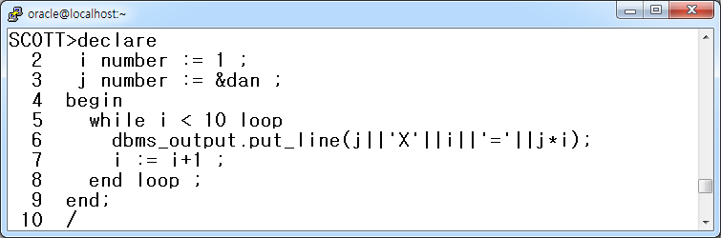

< 17장. PLSQL CURSOR 연습문제 답 >

답 1.
SQL> SET VERIFY OFF
SQL> SET SERVEROUTPUT ON
SQL> DECLARE
2 v_deptno NUMBER := &dno;
3 BEGIN
4 DELETE emp WHERE deptno = v_deptno;
5 DBMS_OUTPUT.PUT_LINE( '삭제 건수는 총 '|| SQL%ROWCOUNT||’ 건 입니다’);
6 END ;
7 /
Enter value for dno: 10
삭제 건수는 총 4 건 입니다

PL/SQL procedure successfully completed.

답 2.
SQL> SET VERIFY OFF
SQL> SET SERVEROUTPUT ON
SQL> DECLARE
2 CURSOR cur_emp IS
3 SELECT ename, sal
4 FROM emp
5 WHERE deptno = &dno;
6
7 v_ename emp.ename%TYPE;
8 v_sal emp.sal%TYPE;
9
10 BEGIN
11 OPEN cur_emp;
12 LOOP
13 FETCH cur_emp INTO v_ename,v_sal ;
14 EXIT WHEN cur_emp%NOTFOUND;
15 DBMS_OUTPUT.PUT_LINE(v_ename||' 의 급여는 '||v_sal||' 입니다');
16 END LOOP;
17 CLOSE cur_emp ;
18 END;
19 /

Enter value for dno: 20
SMITH 의 급여는 800 입니다
JONES 의 급여는 2975 입니다
SCOTT 의 급여는 3000 입니다
ADAMS 의 급여는 1100 입니다
FORD 의 급여는 3000 입니다

PL/SQL procedure successfully completed.

답 3.
SCOTT>alter session set nls_date_format='YYYY-MM-DD:HH24:MI:SS';

Session altered.

SCOTT>declare
2 vdname department.dname%type;
3 vbuild department.build%type;
4
5 cursor d_cur is
6 select dname,build
7 from department
8 where build is not null ;
9
10 begin
11 open d_cur ;
12 dbms_output.put_line(' 학과명과 학과의 위치 안내 입니다');
13 dbms_output.put_line('-------------------------------------------');
14
15 loop
16 fetch d_cur into vdname,vbuild;
17 exit when d_cur%notfound;
18 dbms_output.put_line(vdname||' ---> '||vbuild||' 에 있습니다');
19 end loop;
20
21 dbms_output.put_line('----------------------------------------------');
22 dbms_output.put_line('출력시간:'||sysdate) ;
23 dbms_output.put_line('총 '||d_cur%rowcount||' 건 출력 완료하였습니다');
24
25 close d_cur;
26 end;
27 /

< 19장 Sub Program 연습문제 답 >

프로시저 연습문제 1 답 :
SQL> CREATE OR REPLACE PROCEDURE new_man (
2 v_empno IN emp.empno%TYPE,
3 v_ename IN emp.ename%TYPE,
4 v_job IN emp.job%TYPE,
5 v_manager IN emp.mgr%TYPE,
6 v_sal IN emp.sal%TYPE)
7 IS
8 BEGIN
9 INSERT INTO emp(empno,ename,job,mgr,sal)
10 VALUES(v_empno,v_ename,v_job,v_manager,v_sal);
11 END;
12 /

프로시저 연습문제 2 답:
SQL> CREATE OR REPLACE PROCEDURE up_comm (
2 v_deptno IN emp.deptno%TYPE )
3 IS
4 v_comm emp.comm%TYPE ;
5 BEGIN
6 IF v_deptno = 10 THEN
7 UPDATE emp
8 SET comm = sal*0.2
9 WHERE deptno =v_deptno ;
10 ELSIF v_deptno = 20 THEN
11 UPDATE emp
12 SET comm = sal*0.3
13 WHERE deptno =v_deptno;
14 ELSIF v_deptno = 30 THEN
15 UPDATE emp
16 SET comm = sal*0.1
17 WHERE deptno=v_deptno;
18 ELSE
19 UPDATE emp
20 SET comm = sal * 0;
21 END IF ;
22 END up_comm;
23 /

위 예에서는 변수 2가지가 사용됩니다.
2번 줄과 4번 줄이 그 변수들입니다.
이 두 줄의 차이점은 2번 줄은 사용자에게서 값을 입력 받아 프로시져에게 전달해 주는 변수이며 4번 줄은 프로시저 실행시 프로시저 내부에서만 사용되는 변수입니다.
두 변수의 용도와 위치의 차이를 꼭 기억하세요~

프로시저 연습문제 3 답:
SCOTT>CREATE TABLE emp2
2 AS
3 SELECT * FROM EMP;

Table created.

SQL> CREATE OR REPLACE PROCEDURE del_user(
2 v_empno IN emp.empno%TYPE )
3 IS
4 BEGIN
5 DELETE FROM emp2 WHERE empno=v_empno;
6 end;
7 /

프로시저 연습문제 4 답 :
SQL > CREATE OR REPLACE PROCEDURE select_user(
2 v_empno IN emp.empno%TYPE )
3 IS
4 v_ename emp.ename%TYPE;
5 v_dname dept.dname%TYPE;
6 v_deptno emp.deptno%TYPE;
7 v_sal emp.sal%TYPE;
8 v_comm emp.comm%TYPE;
9 BEGIN
10 SELECT e.ename, d.dname, e.sal, e.comm
11 INTO v_ename, v_dname, v_sal, v_comm
12 FROM emp e, dept d
13 WHERE empno=v_empno
14 AND e.deptno=d.deptno;
15 DBMS_OUTPUT.PUT_LINE('사 번:'||v_empno);
16 DBMS_OUTPUT.PUT_LINE ('이 름:'||v_ename);
17 DBMS_OUTPUT.PUT_LINE ('부 서 명:'||v_dname);
18 DBMS_OUTPUT.PUT_LINE ('급 여:'||v_sal);
19 DBMS_OUTPUT.PUT_LINE ('상 여 금:'||v_comm);
20 END ;
21 /

프로시저 연습문제 5 답:
create or replace procedure d_cal(i_principal number, i_interest number, i_period number) is
cnt number := 1;
month_sang_sum number;
month_sang_wongum number;
month_interest number;
left_wongum number := 1;
pay_total number;
first float := i_principal * i_interest / 12 / ( power ( 1 + i_interest / 12 , 12 * i_period) - 1);
begin
month_sang_sum := round((i_principal * i_interest / 12 + first ));
pay_total := month_sang_sum * 12;
dbms_output.put_line(' ');
dbms_output.put_line(' -------------------------------'||' '||'대출금액:'||round(i_principal/10000.0,0)||'만원');
dbms_output.put_line(' | 대출 원리금 상환 계산기 |'||' '||'대출금리:'||i_interest*100.0||'%'||'('||to_char(i_interest,'0.99')||' )');
dbms_output.put_line(' -------------------------------'||' '||'대출기간:'||i_period||' 년('||i_period*12||'개월)');
dbms_output.put_line('=============================================================');
dbms_output.put_line(' ');
dbms_output.put_line(' 총납입개월:'||i_period*12||'개월/ '||'총납입금액:'||to_char(pay_total,'9,999,999')||'원/ ');
dbms_output.put_line(' 총납입원금:'||to_char(i_principal,'9,999,999')||'원/ '||'총납입이자:'||to_char(pay_total-i_principal,'99,999')||'원');
dbms_output.put_line('------------------------------------------------------------------------------');
dbms_output.put_line('상환 | 월 상 환 | 월상환 | 월상환 | 미 상 환 | 월상환원리금');
dbms_output.put_line('회차 | 원리금합계 | 원 금 | 이 자 | 원리금잔액 | 누적 합계액');
dbms_output.put_line('------------------------------------------------------------------------------'); -- 다음 장에서 계속 됩니다

pay_total := 0;
loop
exit when left_wongum = 0;
month_sang_wongum := round(first * power ( 1 + i_interest / 12 , cnt -1 ));
month_interest := round(i_principal * i_interest /12 + first - first * power ( 1 + i_interest / 12 , cnt -1));
left_wongum := round(i_principal - first * (power ( 1 + i_interest / 12 , cnt) - 1) / ( i_interest / 12 ));
pay_total := pay_total + month_sang_sum;
dbms_output.put_line('*'||to_char(cnt,'09')||' '||to_char(month_sang_sum,'999,999')||' 원 '
||to_char(month_sang_wongum,'999,999')||' 원 '
||to_char(month_interest,'999,999')||' 원 '
||to_char(left_wongum,'999,999')||' 원 '
||to_char(pay_total,'9,999,999')||' 원');
cnt := cnt + 1;
end loop;
end;
/

